Q: Are all of these enough to get full marks in the exam?

A: NO. This is a practice sheet. Meaning, you can practice all you want using the questions from this sheet. However, doing well in exams depends upon your ability to understand a question, formulate an answer, and express it correctly. You see, these are humane skills which cannot be guaranteed by completing a practice sheet only. But yeah, Best of luck anyway.

Chapter 4 (The Processor)

Question - 1:
Draw a diagram of the register file, clearly indicating all input and output pins.
a. Provide a detailed explanation of how the register file performs both read and
write operations.
b. Explain why the size of the read/write register pin is 5 bits.

Question - 2:
Draw a diagram of the ALU, clearly indicating all input and output pins.
a. Explain the significance of the Zero pin in the ALU.
b. Describe how the ALU determines which operation to perform on the given
inputs.

Question - 3:
Draw a diagram of the ALU Control, clearly indicating all input and output pins.
a. Does the ALU control utilize Instruction bits 30 and 14-12 to generate the output for the LD instruction? Provide a justification for your answer.
b. Identify the specific cases in which the ALU control utilizes Instruction bits 30 and 14-12 to generate the output. Additionally, explain why only these four bits (Instruction bits 30 and 14-12) are used in such cases.

Question - 4:
Identify the necessary resources or components from the list provided to construct the datapath for each of the following instructions.

PC | Instruction Memory | Data Memory | Register File | ALU | Immediate Generation Unit | Control Unit | ALU Control

i. | ADD X₂₁, X₂₂, X₂₃
ii. | AND X₂₁, X₂₂, X₂₃
iii. | OR X₂₁, X₂₂, X₂₃
iv | ADDi X₂₁, X₂₂, 5
v. | LD X₂₁, 22(X₂₁)
vi. | SD X₂₁, 22(X₂₁)
vii | BEQ X₂₁, X₂₂, End

Question - 5:
Draw a simplified datapath with control unit that can process ADD X21, X22, X23

Question - 6:
Draw a simplified datapath with control unit that can process ADDI X21, X22, 5

Question - 7:
Draw a simplified datapath with control unit that can process LD X21, 14(X22)

Question - 8:
Draw a simplified datapath with control unit that can process only the following codes:
LD X21, 14(X22)
SD X22, 16(X21)
Mention the control signals also for each instructions.

Question - 9:
Draw a simplified datapath with control unit that can process only the following codes:

ADDI X21, X22, 5
LD X21, 14(X22)
Mention the control signals also for each instructions.

Question - 10:
Draw a simplified datapath with control unit that can process the following codes:
ADDI X21, X22, 5
LD X21, 14(X22)
Mention the control signals also for each instructions.

Question - 11:
Modify the BEQ datapath so that it works for BNE.

Question - 12:
Construct a single-cycle full-datapath, ensuring that you use only 4:1 multiplexer(s) wherever multiplexer(s) are required.

Question - 13:
Suppose that in a buggy implementation of the RISC V datapath, the AND gate for the branching decision was replaced with an XNOR gate. Describe how this error would affect the execution of the following instruction.
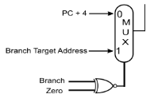
i. SUB x1, x2, x3 [3 points]
ii. BEQ x1, x2, target [3 points]

Question - 14:
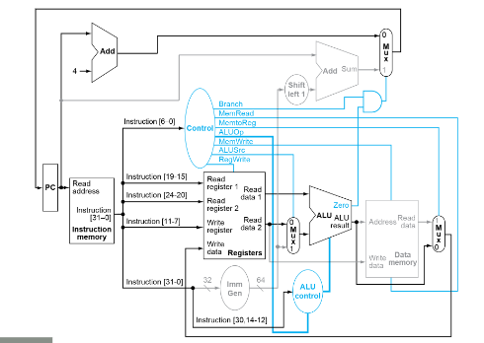
Determine the values of the following control bits when executing the instruction "Add X21, X22, X23" in the provided single-cycle datapath.

Branch | MemWrite | RegWrite | ALUSrc

Question - 15:
Determine the values of the following control bits when executing the instruction "Addi X21, X22, 12" in provided single-cycle datapath for Q-14

Branch | MemWrite | RegWrite | ALUSrc

Question - 16: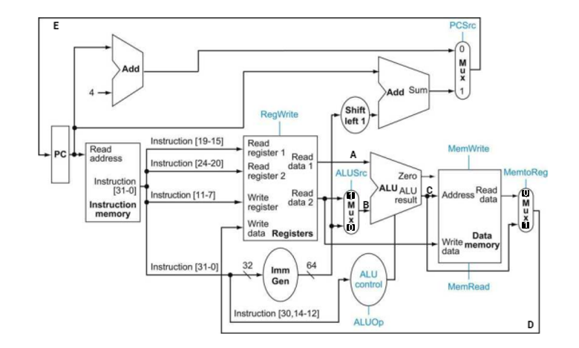
Determine the values of the following control bits when executing the instruction "Add X21, X22, X23" in the provided single-cycle datapath.

Branch | ALUSrc | RegWrite | MemToReg

Question - 17:
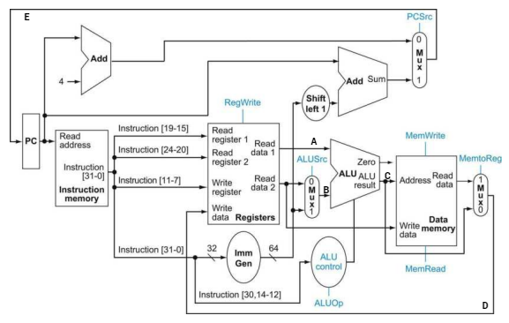
Study the above RISC-V Datapath thoroughly. Assume that initially PC=600_{h}, x₁ = 222_{h}, x₂ = 444_{h}, x₃ = 666_{h}, x₄=999_{h}.
Determine the values of A, B, C, D, E in hex for the instructions executed sequentially. If the value does not matter, write it as X (don’t care)

 |  | A | B | C | D | E
i. | sub x₁, x₂, x₁
ii. | sd x₄, 12(x₂)

Question - 18:
Carefully examine the RISC-V datapath provided in Q-17. Assume the initial values are: PC = 600h, x1 = 222h, x2 = 444h, x3 = 666h, and x4 = 999h. For the following instructions executed sequentially, determine the hexadecimal values of A, B, C, D, and E. If the value is irrelevant, indicate it as X (don't care).

i. | sub x₁, x₂, x₁
ii. | sd x₄, 12(x₂)
 |  | PC | A | B | C | D | E
iii. | Addi x₁, x₁, 12

Question - 19:
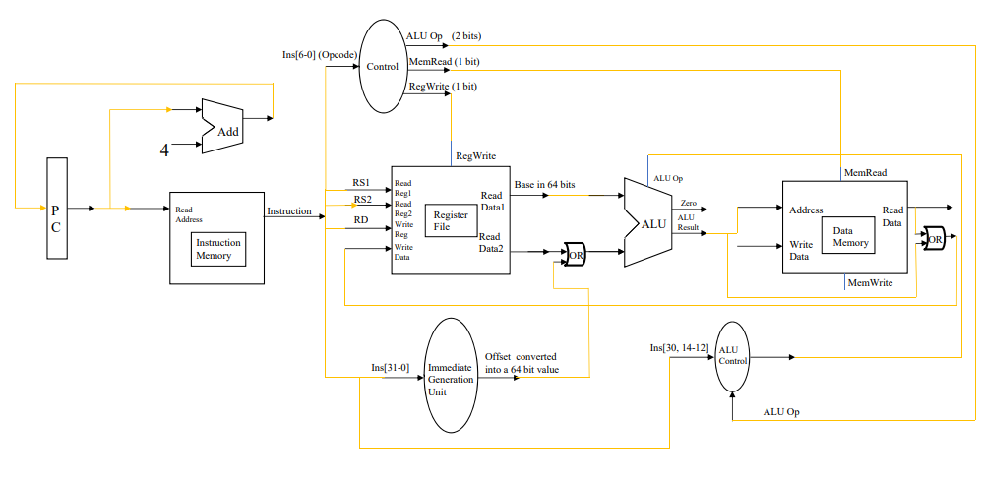Given the following code sequence:

1. ADD X1, X2, X3
2. LD X5, 10(X4)
3. OR X2, X3, X23

Is it possible to execute this code sequence using the provided datapath? If not, correct the datapath.

Question - 20:
Assume the memory is following Big Endian approach.
PC = 0x0040ABCD123045B1
Instruction Memory:  Address Content  0x40ABCD123045AD 0111 0101  ………………………… 1011 1110  ………………………… 1001 0001  ………………………… 1100 0000  ………………………… 0000 0001  ………………………… 1001 0101  ………………………… 0000 0101  ………………………… 0011 0011 | Data Memory:  Address Content  0x40ABCD123045AD 0111 0101  ………………………… 0111 0100  ………………………… 1000 0000  ………………………… 1000 0001  ………………………… 0000 0000  ………………………… 0001 0111  ………………………… 1000 0101  ………………………… 1111 0011
Fetch the instruction from memory. Convert your answer in Hex.

Question - 21:
The following table shows the different stages involved in executing instructions and the corresponding durations for each stage:
stages | Instruction  Fetch | Register Read | ALU Op | Memory Access | Register Write
Duration | 50ps | 10ps | 30ps | 20ps | 10ps

Given the above durations, determine the total time required to complete each of the following instructions:

 | Instructions | Time to complete each instructions
i. | ADD X₂₁, X₂₂, X₂₃
ii. | AND X₂₁, X₂₂, X₂₃
iii. | OR X₂₁, X₂₂, X₂₃
iv | ADDi X₂₁, X₂₂, 18
v. | LD X₂₁, 22(X₂₁)
vi. | SD X₂₁, 22(X₂₁)
vii | BEQ X₂₁, X₂₂, End

Question - 22:
Instruction | Time (PS)
Add X21, X22, X23 | 10
Sub X21, X23, X24 | 20
Mul X22, X23, X26 | 15
LD X22, 0(X21) | 25

The above instructions are being run in a single cycle datapath.
a. Now determine what is the clock period of this system?
b. What would be the total time to run this instruction sequence?

Question - 23 :
What do you understand by the term "single-cycle" in the context of a single-cycle datapath?

Question - 24 :

Stage | IF | ID | EX | MEM | WB
Time (PS) | 10 | 20 | 20 | 20 | 10

The below instructions are being run in a pipelined datapath. Calculate the time required to execute each instruction.

Instruction | Time (PS)
Add X21, X22, X23
Sub X21, X23, X24
Mul X22, X23, X26
LD X22, 0(X21)

Determine what is the clock period of this system?

Question - 25 :
Write a comparison between the single cycle datapath and a pipelined datapath. Mention why pipelined datapath is implemented in real life.

Question - 26 :
In the RISC-V pipelined datapath we have 5 stages. Can we divide these 5 stages into more stages to make the datapath more efficient?

Question - 27 :
Explain Why do data hazards occur in a pipelined Data path?

Question - 28 :
The instructions provided below are executed sequentially within a pipelined datapath that is divided into five stages, as depicted in the following diagram. In the diagram, the gray shaded areas represent the periods when tasks are actively being processed in each stage, whereas the unshaded (white) areas indicate inactive portions of each stage.
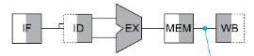

Instruction
Add X21, X22, X23
Sub X21, X21, X24
Mul X22, X21, X26
LD X22, 0(X21)

Will any data hazards occur during the execution of this instruction set? If so, identify the number of data hazards and clearly circle them.

Question - 29 :
What do you understand about structural hazards? Explain with an example.

Question - 30 :
The instructions provided below are executed sequentially within a pipelined datapath that is divided into five stages, as depicted in the following diagram. In the diagram, the gray shaded areas represent the periods when tasks are actively being processed in each stage, whereas the unshaded (white) areas indicate inactive portions of each stage.


Instruction
Add X21, X22, X23
Sub X21, X20, X24
LD X22, 0(X22)

a. Will any data hazards occur during the execution of this instruction set? If so, identify the number of data hazards and clearly circle them.
b. How many clock cycles are necessary to run this instruction set?

Question - 31 :
The following are the time requirements for various stages of a datapath:

1. Instruction Fetch: 25 ps
2. Instruction Decode: 10 ps
3. Register Read: 15 ps
4. Arithmetic or Logical task execution: 20 ps
5. Data Memory Read: 20 ps
6. Data Memory Write: 20 ps
7. Register Write: 25 ps

You are given the following instruction set, executed sequentially:
1. Add X21, X22, X23
2. Sub X21, X23, X24
3. Mul X22, X22, X26
4. LD X22, 0(X20)

Suppose this instruction set is executed sequentially in a single cycle datapath. Answer the following:
a. Calculate the actual time required to execute each instruction.
b. Determine the clock period of this system.
c. Calculate the number of clock cycles needed to execute this instruction set.
d. Determine the total time required to execute this instruction set.

Now, assume the instruction set is executed sequentially in an ideal pipelined datapath with 5 stages.
Answer the following:
a. Calculate the actual time required to execute each instruction.
b. Determine the clock period of this system.
c. Calculate the number of clock cycles needed to execute this instruction set.
d. Determine the total time required to execute this instruction set.

